Nombre: ____________________________ Bloque: ________ Fecha: _______________________
Español 1 - Unidad 4 – La cultura – España
Instrucciones: Fill out the following notes sheet based on the cultural activities online. This follows the online activity in order by section. Make sure to hold on to this paper to study, as this information will be part of the exam! This can also be used as a backup should you lose internet connection while working.

Información general:
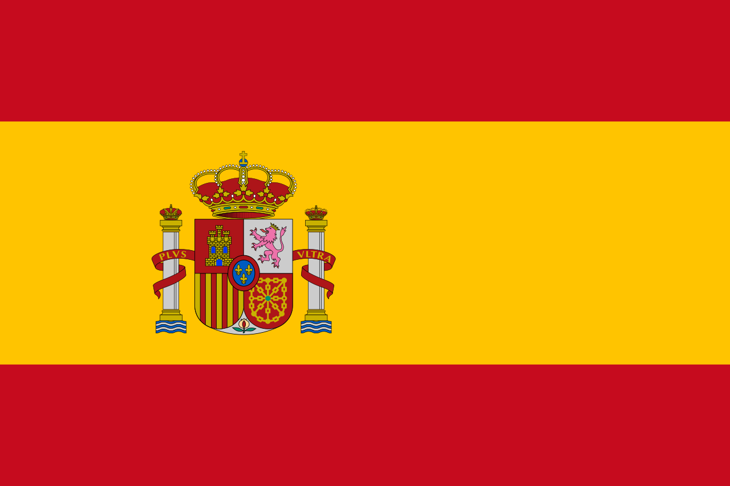
- The capital of Spain/España: ____________________________
- Three typical foods: ____________________________________

- Currency of Spain: ____________________________
Colors/Design of the Spanish Flag: ________________________
________________________
- Ocean that boarders Spain: ____________________________
- Country to the west: ____________________________
- Sea to the east _______________________.
El fútbol:
- Himnos oficiales or official songs are an important part of _____________________________ games in Spain.
- Two soccer teams from Spain are _____________________ & their rival team FC Barcelona or El Barça
Picasso:
- Pablo Picasso is a famous _______________________ of the 20th century that used many traditional Spanish themes in his work.
- The painting, Don Quijote, by Picasso features Don Quijote and ________________________ from the famous novel.
- ___________________________ wrote the novel about Don Quijote.
Sevilla, las sevillanas y el flamenco:
- Girls wear el traje sevillana or a traditional costume during __________________________, which takes place in Sevilla, España.
- ______________________ are similar to flamenco which involves singing, dancing, guitar playing, along with rhythmic foot taps and clapping.
El arte surrealista:
- Salvador Dalí is a famous artist from Spain known for his ________________________ paintings.
- Surrealist paintings reflect an artist's imagination and are often inspired by _____________________.
- The Persistence of Memory is Dalí's masterpiece, or one of Dalí most famous paintings and features melting _________________________.
Climates:
- Countries near the equator have rainy and dry seasons, but are ________________________ year round.
- July in Spain is a ______________________ month.
- July in Chile is a _____________________ month.
- Countries in the northern and southern hemispheres have _____________________ seasons.
- Chile's ___________________________ creates many different climates within the country.

Mercados:
- ____________________________ is one of the oldest Spanish flea markets in Madrid, Spain where many people go on Sundays to look for bargains.
- People go to the El Rastro market in Madrid looking for deals on second hand clothing, antiques, CDs, books, maps and ____________________.
- In ________________________, Chichicastenango also holds a popular market with handicrafts from the Maya-Quiché culture.
- Vendors at the market in Chichicastenango wear ______________________ of their region and sell colorful textiles, fruits and vegetables, masks, baskets, candles and flowers.
- Huipiles are Mayan ______________________.
Diego Velázquez:
- Diego Velázquez was a famous Spanish painter and served as the official painter for ________________________ Philip IV of Spain.
- Velázquez painted many ________________________ of the royal family.
- Las Meninas, one of Velázquez's most famous paintings, shows la infanta or the _________________ and her attendants.
- In Las Meninas, Velázquez also included ________________________ in the painting.
- Three hundred years later, _____________________ painted 58 interpretations of Las Meninas.

